**Assessment Cover Page**

|  |  |
| --- | --- |
| *Student Full Name* | Derek O’Hara |
| *Student Number* | sbs24018 |
| *Module Title* | Storage Solutions for Big Data |
| *Assessment Title* | CA2 |
| *Assessment Due Date* |  |
| *Date of Submission* |  |

**Declaration**

By submitting this assessment, I confirm that I have read the CCT policy on academic misconduct and understand the implications of submitting work that is not my own or does not appropriately reference material taken from a third party or other source.

I declare it to be my own work and that all material from third parties has been appropriately referenced.

I further confirm that this work has not previously been submitted for assessment by myself or someone else in CCT College Dublin or any other higher education institution.

Contents

Introduction 1

Chapter 1 1

Chapter 1.1 1

Chapter 1.1.1. 1

References 2

# Assessment Task

## Question 1

Define Big Data and outline its key characteristics. Discuss the potential for banks to increase profits through big data processing and analysis. Identify three businesses that have successfully leveraged big data storage solutions in recent times. (10 Marks)

## Answer

Big data refers to extremely large and complex data sets that cannot be easily managed or analysed with traditional data processing tools, particularly spreadsheets (Oracle, 2024). Big Data includes diverse formats, such as structured, semi-structured, and unstructured data from a wide range of sources like social media, sensors, transactional activities, and more.

**Main Characteristics of Big Data:**

Traditionally, big data was recognised by three characteristics known as the “three Vs”: variety, volume, and velocity. Over the past few years, two additional Vs have emerged: value and veracity.

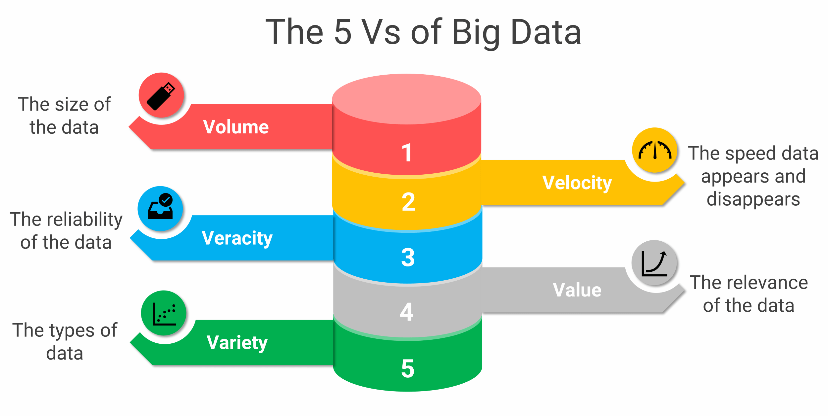

Fig 1. 5Vs of Big Data (Passionned Group. 2024).

**Potential for banks to increase profits through Big Data:**

Banks can increase their profits significantly by ramping up their Big Data capabilities in the following ways:

* **Customer profiling:** By analysing transactional and behavioural data, banks can offer personalized financial products and services, boosting customer satisfaction and loyalty.
* **Fraud detection:** Real-time Big Data processing enables banks to identify potential fraudsters swiftly, minimizing losses.
* **Decisions on lending:** Big Data can streamline loan approvals and decision-making processes, which can be optimized or even automated.
* **Compliance with regulations:** Big data analytics and BI tools go a long way in making the task of compliance with regulations easier.
* **Cybersecurity:** While cyber-attacks have been growing, banks are looking towards big data analytics and AI tools to improve their cybersecurity because threats from inside the organizations have also started emerging. (V. Zubenko, 2023)

**Three businesses that have successfully leveraged big data storage solutions:**

* **Uber:** Big data in route optimization, demand estimation, and dynamic pricing are applied. Gathering enormous pieces of information on GPS, traffic patterns, and user behaviour, Uber analyses the data in real time to fit ride-matching. It actively predicts rider demand to study scheduling. This helps in improving the experience of users and reduces costs. (ProjectPro, 2024)
* **Spotify:** Spotify uses big data in recommending music and curated playlists to users, each according to taste. Using machine learning by analysing user listening habits, playlists, and genre preferences, Spotify predicts and recommends songs that their users are likely to enjoy. This personalisation keeps them on the platform for longer periods of time and raises subscription revenue. (Y. Müstecaplıoğlu, 2024)
* **John Deere:** Agricultural machinery company John Deere installs big data and IoT devices in its agricultural machinery. These devices will give actionable data with respect to crop health, soil quality, and weather conditions. This sets of information, therefore, aids farmers right from planting to harvest with optimized yield and minimal wastage. They help farmers speed up profitability and efficiency by providing actionable insights into data and, in the process, enhance their relationship with customers and their service offerings.

# References

Oracle. (2024). What Is Big Data? Available at: <https://www.oracle.com/ie/big-data/what-is-big-data/>

Fig 1. 5Vs of Big Data: Passionned Group. (2024). Big Data Analytics: Definition, Pros and Cons, Applications, Opportunities, and Risks. Available at: <https://www.passionned.com/big-data/>

Valentyn. Zubenko (2023) How big data changes the scope of modern banking. Available at: <https://www.avenga.com/magazine/how-big-data-changes-banking/>

ProjectPro. (2024). How Uber Uses Data Science to Reinvent Transportation. Available at: <https://www.projectpro.io/article/how-uber-uses-data-science-to-reinvent-transportation/290>